##### KATE SMALL IN PATENT LEATHERF

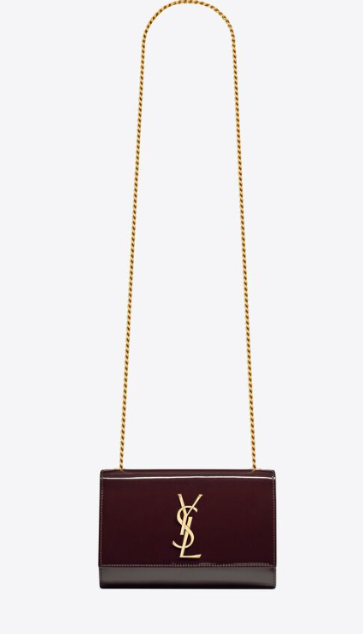  
The "Kate Small" bag is a popular design by the luxury fashion house Saint Laurent. Known for its sleek and sophisticated style, the Kate bag is a timeless accessory that adds a touch of elegance to any outfit. The "Small" size indicates that it's a compact version of the bag, ideal for carrying essentials while maintaining a chic silhouette.

When crafted in patent leather, the Kate Small bag exudes a glossy and polished appearance. Patent leather is a type of coated leather that has a high-shine finish, making it eye-catching and luxurious. This material choice adds a modern twist to the classic design of the bag and makes it stand out.

The Kate Small bag typically features a signature YSL monogram logo plaque on the front flap, a chain shoulder strap that can be worn crossbody or doubled up for a shorter shoulder carry, and a magnetic snap closure. It's available in various colors to suit different style preferences and occasions.

If you're interested in purchasing the Kate Small in patent leather, you can explore Saint Laurent's official website or visit their boutique stores to see the latest offerings. Additionally, you can check with reputable luxury retailers or online platforms specializing in designer handbags to see if they have this specific bag available for purchase.